**Fall 2018: EEL-6935 Smart Grid – Homework 04 1. Controllability and Observability.**

**Hector Lopez**

In this problem you’ll explore the controllability and observability of the linear system that we discussed in class, representing heating and cooling a room. For the configuration in the slides:

1. (a)  Using the constants *k* = 0.2 , *d* = 0.05 , and Δ*t* = 0.05 , determine if the system is controllable. You should do this using MATLAB and the rank command.

*The system is controllable because it has independent columns when ranking Ak :*

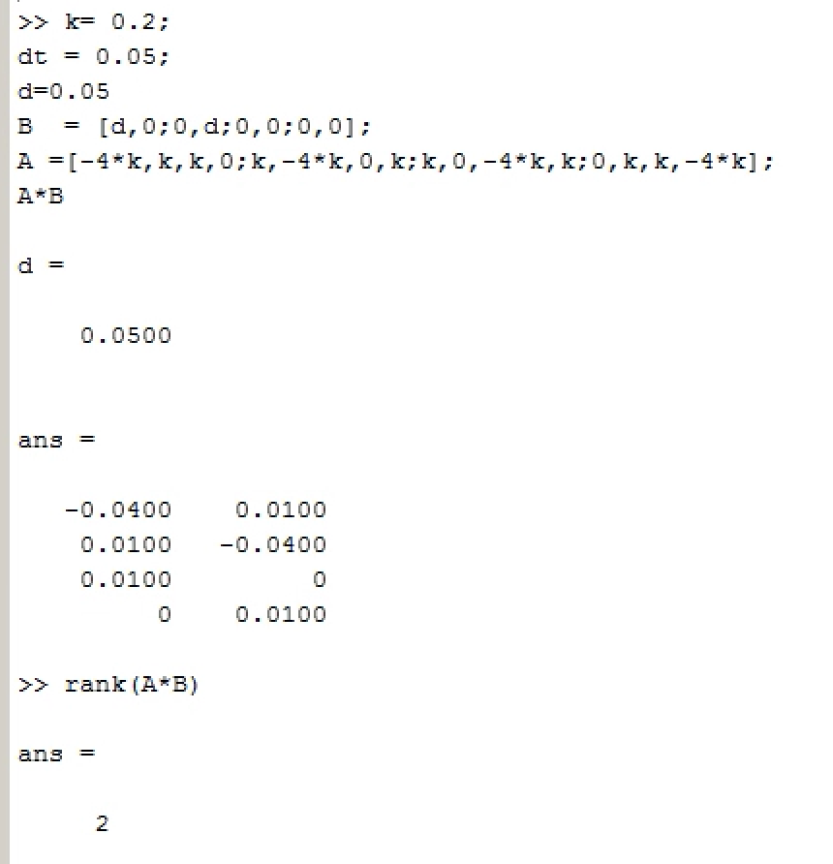

1. (b)  Find the dynamical systems and determine controllability for the cases where (i) there is only one heater/cooler in Room 1 and (ii) there are heaters/coolers in rooms 1 and 4. Intuitively describe (in a sentence or two) why the controllability is or is not different from the case in part (a)

**2. Control via least squares. [50 pts]**

In class we discussed how optimal control in linear dynamical systems with quadratic costs can be solved using the LQR algorithm. Here we’ll show that these problems (for a finite horizon) can also be solved as least squares problems, though this is typically less efficient that the LQR solution. Consider the linear dynamical system:

(a) Consider the vectors formed by concatenating the control and state vectors:

(b) Using the above relationship, show that we can solve the optimal control problem:

can be solved using a least squares formulation: specify some *H* and *c* (defined in terms of F and g from the previous problem) such that:

gives the optimal solution to the optimization problem above.